**Experiment 4**

**Aim** :- Experiment to execute memory management and user management commands.

**Theory**:-

**User Management Commands**:- User management is nothing but adding, deleting the users and assigning the passwords for the users in Linux. The same follows with groups. The important thing is this command needs root privilege for accessing other users or groups. Only the same user process can be done without the privilege.

**Memory Management Commands**:- Linux is one of the most popular open source operating system and comes with huge set of commands. The most important and single way of determining the total available space of the physical memory and swap memory is by using “free” command.

The Linux “free” command gives information about total used and available space of physical memory and swap memory with buffers used by kernel in Linux/Unix like operating systems.

**Commands:**

**User Management Commands:**

**Sudo adduser username -> To add a new user to to the OS**

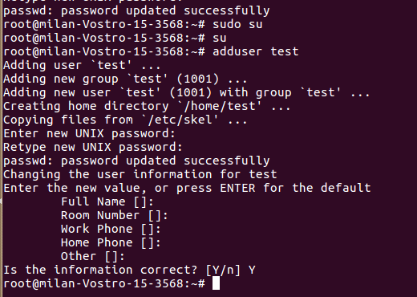

**Sudo passwd username -> To change password of user**

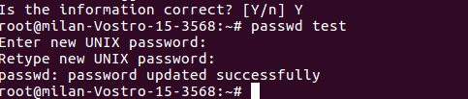

**Sudo Groupadd groupname -> To add a group**

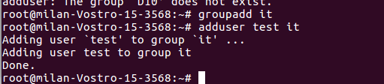

**Sudo deluser username groupname -> To delete user from a group**

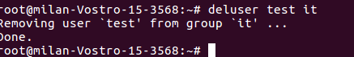

**sudo chown username filename -> To change ownership of a file to user**

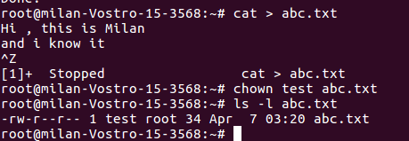

**Sudo chgrp groupname filename -> To change group of a file**

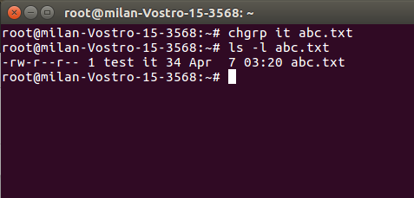

**\*\*\*\*\*\*\*\*\*\*\*\*\*\*\*\*\*\*\*\*\*\*\*\*\*\*\*\*\*\*\*\*\*\*\*\*\*\*\*\*\*\*\*\*\*\*\*\*\*\*\*\*\*\*\*\*\*\*\*\*\*\*\*\*\*\*\*\*\*\*\*\*\*\*\*\*\*\*\*\*\*\*\*\*\*\*\*\*\*\*\*\*\*\*\*\*\*\*\*\*\*\***

**Memory Management Commands**

1. **$fdisk -v**

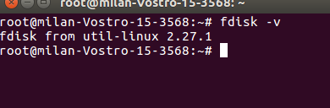

1. **$fdisk -l**

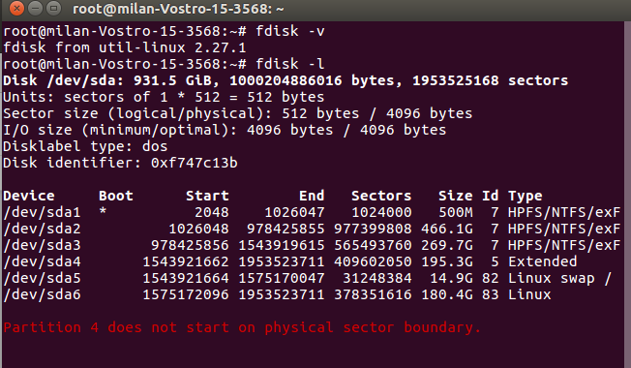

**3.$df**

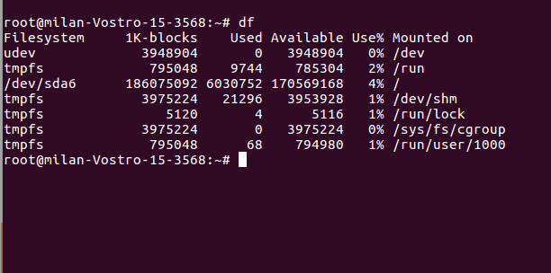

**4.$du -h**

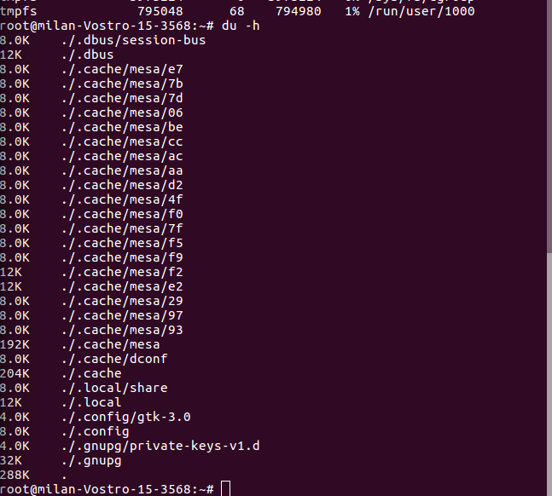

**Conclusion** :- Thus we have studied about various user management and memory management commands.